RedLadies: TRI 101 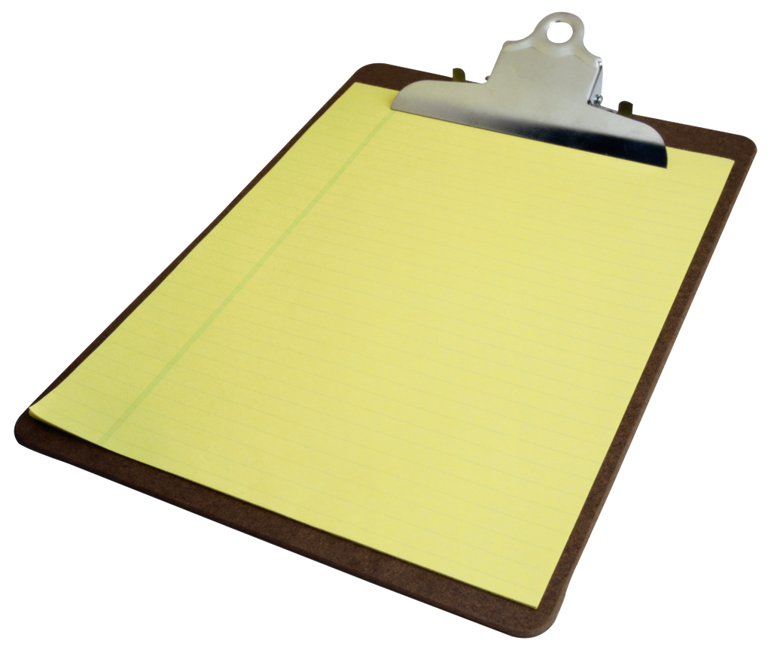
Welcome Reds!

Have information you think other Reds would find helpful? Please email Liz so she can include it. Thanks in advance for your input!

Bike 101
Equipment Basics: You can keep bikes simple or can get very involved w/ all the equipment. Whatever you do, just make sure you ask questions if you don’t know.

Bike (road or tri bike)
Shoes (bike shoes that clip into your bike pedals)
Helmet
Cell phone – always carry one when you bike
Road ID – a wrist or ankle bracelet with your emergency contact information
Money – always a good idea to carry a bit with you when you ride.
Route – KNOW YOUR ROUTE! Look at a map before you leave and carry directions w/ you if you need to – this helps us all stay safe : )

Equipment to change a flat (we will go over this)
*tire levers
*CO2 / portable pump
*spare tube

Bike or tri shorts (the difference is that tri shorts have less padding in the crotch than bike shorts – this is b/c triathletes often swim in their shorts and so lots of padding gets in the way!)

Bike jerseys – main reason these are impt are for the pockets in the back which allow you to carry food, equipment for tire changing, money etc

Socks / bike gloves – some people wear these when they ride, some don’t

Cold weather gear – bike tights, jackets, gloves, head gear etc. Lots of gear to pick from with this – personal preference is what matters.

Shammy butter / butt butter – you will discover, as all of us have, that riding can produce some interesting “hot spots” in your nether regions : ) Shammy butter lubs things up and can help prevent rubbing and rashes. ….we all deal w/ this so pip up if you have issues!

Aerobars – these are the bars you see on the front of people’s bikes which allow them to go into “aero position” – it’s a position that makes you more aero dynamic. Triathletes use these – people who are strictly “bikers” generally don’t.

Sunglasses – even on cloudy days, they help keep debris from flying in your eyes

Bike fit – Perhaps one of the most important things you can do right from the start is to get a good bike fit. A bad bike fit can cause shoulder, back, hip, knee issues and more – and often you don’t realize that it’s the bike that is the problem (for example, your knee hurts when you run – might very well be from a stinky bike fit). If you only invest in 1 thing this year, this is it.

Vendors:
Elite – 103 and Mission
Trek – Shawnee Mission Parkway
Bike Source
Mike X (bike fit)
Whitey
Nashbar.com – online/discount

Run 101
Equipment Basics
Shoes – get good ones, don’t wait too long to replace them

Lace Locks – Ties your laces so you don’t have to; makes for quick transitions during a triathlon.

Vendors
New run store
Garry gribbles
Road runners (online)

Swimming 101
Equipment Basics:
Swim suit – a “racing” suit will provide better support but any suit will do.
Cap – keeps the hair out of your face
Goggles – clear and “sunglasses” (the ‘sunglass’ ones are good to race in when it’s sunny)
Wetstuit – Many variations to chose from; wetsuits protect you from the cold but most triathletes like them b/c they make you float in the water b/c they are made of a rubbery material. These are allowed in swims where the water is 71 degrees or less.

Vendors:
Swim Outlet.com (online)
Dicks
Swim Quick

Tools for learning to swim: ask for help!!
Go Swim TV
Total Immersion
Masters Practices

* you need to learn to swim both in the pool and in the open water. They are 2 different things and need to be approached as such.

Basic Swim Lingo:
There are 4 competitive strokes in swimming:
Freestyle / The Front Crawl – the “main” stroke in swimming
Breast Stroke/Backstroke/Butterfly – the other 3 competative strokes

IM = Individual Medley (Individual = 1 person. Medley = a medley of the 4 competitive strokes listed above). You will hear this if you go to a Masters practice – something to ask the coach on deck about.

Drills – drills are things that you do to work on technique. There are lots of drills you can do in swimming – the important thing is that you figure out what drills you need to use to improve your stroke. The best way to do this is either through a swimming lesson or to ask a swim coach during a masters practice. Drills are a waist of time unless done correctly and in a way that’s relevant to your stroke. Go Swim TV is a great place to view swimming drills.

Yards and/or Meters – most pools are in yards. 1 length = 25 yards, 2 lengths = 50 yards, 4 lengths = 100 yards etc. Meters are slightly longer than yards – but still measured in 25 meters / 50 meters, etc.

Interval – How much time you have to swim something. Example: 4 x 50 yards on a 1 minute interval. You have 1 minute to swim 50 yards (2 lengths). If it takes you 50 seconds, you have 10 seconds to rest before you go again.
NOTE: Many times instead of an “interval” you will simply use “rest”. 4 x 50 with 15 seconds rest between each. This is easier – though not as hard physically.

Swimming Pools and Masters Teams
NOTE: When you join a masters team, you will need to tell the coach you are new to swimming and/or masters. It may take a while to get used to swimming with masters - they may swim more than you need to (then just get out early or modify what they give you), you may not understand the swimming lingo (ask! You really have to ask – otherwise you surely won’t ever figure it out) – the coaches are there to help you, so use them : ) Masters teams usually include “swimmers” and “triathletes” – so the practices are trying to accommodate both. You can adjust what you do – and if you need help with this – yes, ask the coach on deck.

Places to find Masters Programs:
Your local gym – pool and/or masters team

Pool – Roeland Park Aquatic Center
Pay per time; doesn’t require membership. Approx $5 per visit

Jewish Community Center
$10 to get into JCC if you’re not a member
Tues /Thurs at 5:45 AM form & Technique / Coach Dave
Mon/Wed/Fri – noon practice (not form and technique)

Blazers Masters Program / $5
http://www.teamunify.com/SubTabGeneric.jsp?_stabid_=1210&team=mvskcb

Open Water Swimming:
Shawnee Mission Park – early May through August / $6
Site:

Longveiw Lake – Memorial Day through Labor Day
http://www.jacksongov.org/content/3279/3763/default.aspx

Kill Creek
http://jcprd.com/parks_facilities/kill_creek.cfm

Lake Quivera – you need to know someone who lives at LQ to get in here – but it’s a great spot if you can get access

Weights
Weights are an important part of triathlon training. You will do more weight lifting in the start of the season than at the end (weights fade out as you start to focus more on endurance the farther you get into your season). Perhaps the most important part of any weight routine is core – a strong core is critical for injury prevention and making you faster.

While your plan will include basic weight lifting exercises, if you would like something specific to your needs, it would be a good idea to visit a personal trainer or a fitness professional who can assess your strengths, weaknesses, muscle imbalances and can create a program that will address these needs specifically for you.

Nutrition
“What’s your nutrition” is a phrase you’ll hear a lot. “Nutrition” usually refers to what AND when you eat on the bike and run. Figuring this out is as important as the physical training you do – there are lots of products to pick from and you will need to experiment to see what works best for you. We will talk a lot about this – and you’ll take the year to figure this out.

People generally take – water, sports drink, Gels (a carbohydrate gel), salt, sports bars, peanut butter/tortillas….that’s a general list which doesn’t include any name brands or specific products – that will come later.

Misc Lingo
Heart Rate
RPE
Pace
Heart Rate Zones – what they are / how you figure out yours
LT Test
Off Season
Build / Base / Peak / Recover
Recovery

